**Form (Feedback forms)**

* Conference feedback form
* Session feedback form
* Feedback form can be viewed according to the logged user
* With option to view conference or session feedback
* Feedback section associated with the feedback form is also displayed in the second table
* To add a feedback form click “Add Feedback” button to add a feedback tot database that can be linked later to a conference or session.
* To add section to feedback form click “Add Section” button and add required section to a feedback form.

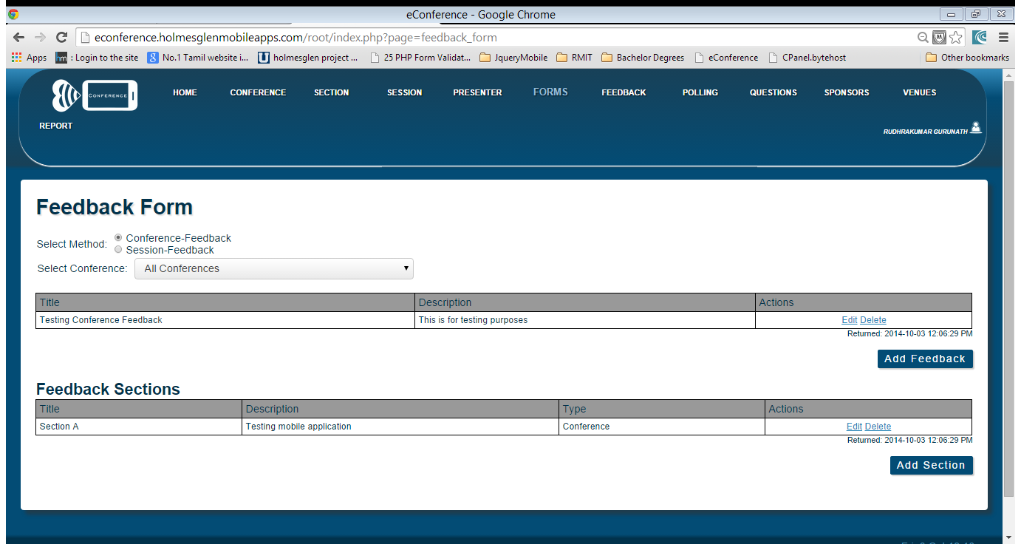

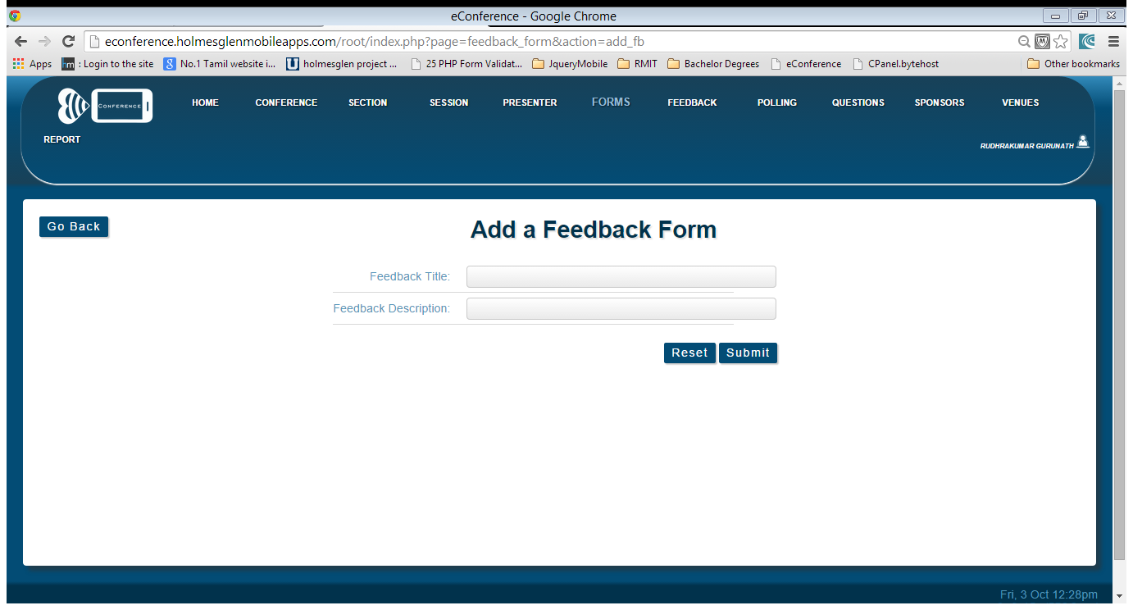

Add Feedback Section

* In this form select the feedback form to enter the detail of section and submit the details.

